# **HOA and**

**Rental Program**

**Guide for Owners**

TABLE OF CONTENTS

Table of Contents

[Silver Dunes Mission and Values 3](#_Toc20557255)

[Meet the Team 4](#_Toc20557256)

[Stay Connected 6](#_Toc20557257)

[Why is Silver Dunes Such a Wonderful Place to Invest in Your Vacation Home? 7](#_Toc20557258)

[Property Layout and Amenities 9](#_Toc20557259)

[Silver Dunes HOA and Financial Structure 12](#_Toc20557260)

[Silver Dunes In-House Rental Program 13](#_Toc20557261)

[Housekeeping Services and Property Inspections 19](#_Toc20557262)

[Maintenance Services 20](#_Toc20557263)

[HOA Dues and Pricing of Supplemental Services 21](#_Toc20557264)

[Recap of Service Offering and Pricing 22](#_Toc20557265)

[Owner Booking Form (form to be completed for guests of non-rentals) 24](#_Toc20557266)

[Questions, Comments? 25](#_Toc20557267)

# C:\Users\Pam\Pictures\65826423_2456723194372987_6420365397530247168_n.jpg

# Silver Dunes Mission and Values

Silver Dunes is a beautifully landscaped eight-acre vacation condominium complex directly on the Gulf of Mexico in Destin, Florida. As one of the most well-known and well-established vacation condominiums in the area, our 98 owners take pride in the culture we have created for our “little piece of heaven.”

Our mission and values are:

* **Family.** Silver Dunes is a family-focused vacation destination.
* **Service.** We strive to give our owners and guests an excellent vacation experience, hoping they will return to Silver Dunes year after year.
* **Team.** Our Silver Dunes management and staff lives by the golden rule –treat everyone as you want to be treated. Our work culture focuses on the values of treating everyone with respect, being open to new ideas, and encouraging continuous improvement. Not only do we want Silver Dunes be known as “the place you want to be,” we also want it to be known as “the place residents of Destin want to work.” Our employees are recognized for hard work and customer service– we strive to make employees feel appreciated, valued, paid fairly, and offered excellent benefits.
* **Board.** Our board is comprised of nine Silver Dunes owners, who are elected to represent the interests of all 98 owners. The board has a fiduciary responsibility to make decisions in the best interest of the association, all owners, and employees.
* **Investments.** Collaboratively with the board, owners, and Silver Dunes management, we maintain a long-term vision and capital plan for the Silver Dunes complex – making wise investment decisions to maintain and enhance the value of the property and its appeal to our owners and guests.

# Meet the Team

While most complexes in Destin are managed by outside agencies, Silver Dunes is not.  We have property management, accounting, leasing, security, maintenance, and housekeeping all on-site – and solely dedicated to service at Silver Dunes.  Our housekeeping team provides excellent cleaning and inspection services; our security team provides peace of mind, our accounting manager provides financial reporting for all owners in the rental program; the front desk manages reservations and responds to guests needs; and our management team is here to make the property and the rental program the best the best it can be.



*Derek Maxwell, General Manager –* From the first day I started I knew Silver Dunes would become my second home. Silver Dunes has become home to many of us and I thankful for the opportunity of becoming part of the family.



*Denise Dorsey, Accountant -* Work for me here at Silver Dunes is rewarding.  I believe in going the extra mile because it is a place filled with opportunities.



*Andy Kameenui, Director of Maintenance -* Silver Dunes is outstanding work environments that will allow me to grow as an employee while watching Silver Dunes accomplish new and wonderful things.

*Amber Kameenui, Rental Manager* – Silver Dunes has given me a chance to meet people from all different walks of life while creating new memories to share.



*Pat Moorer, Director of Housekeeping* – I love working at Silver Dunes. This is the happiest job I’ve ever had and will be the last because I wouldn’t choose to work anywhere else.



*Chris Trafton - Beach Service Manager* – In 1999 my parents moved us down from Tennessee to this beautiful area that we all call the Emerald Coast. It didn't take much to make me fall in love with this place and within a couple of years I had my first beach job. From that point on I knew that the beach life was for me! Today we have a handful of beach service equipment and offer chair/umbrella rentals, stand up paddle boards, kayaks, as well as a few beach games (corn hole, spike ball). Words cannot express how excited, grateful, and happy we are to be at Silver Dunes!

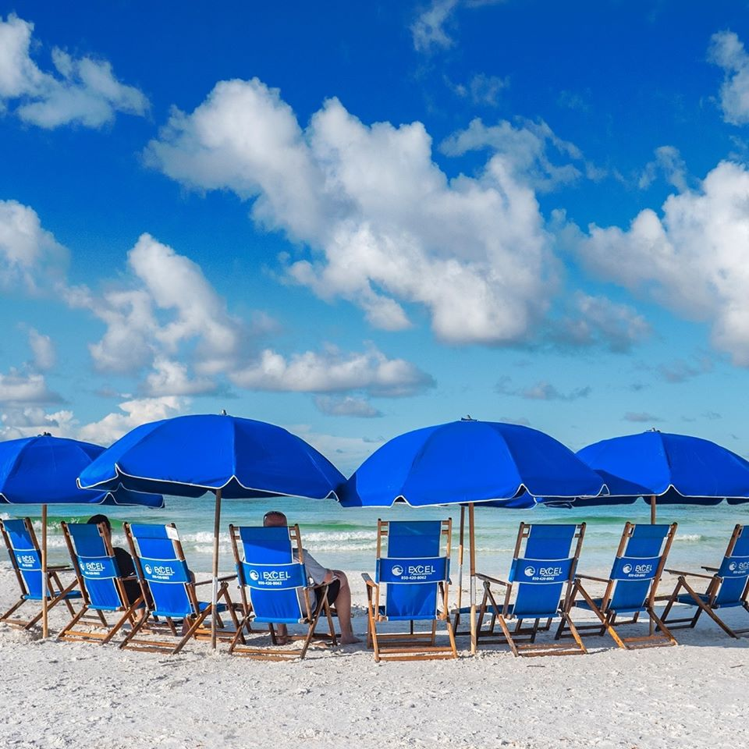

# Stay Connected

Annual Owners Meeting

Silver Dunes hosts its annual owners meeting every fall. There is an owners’ poolside reception that Friday evening, followed by a formal meeting Saturday morning. Votes are counted and board election results are announced during this annual meeting.

Meeting logistics and candidate resumes are sent via mail prior to each year’s meeting.

Updates via Email and USPS Mail

Periodically throughout the year, the Silver Dunes property manager and the Board share news and announcements via letters, reports, etc.

Facebook HOA Page

Silver Dunes has a private Facebook page for all owners (titled Silver Dunes HOA). This is an excellent way to stay connected throughout the year on property initiatives. Owners also leverage this forum to request recommendations for vendors, restaurants, share tips, etc.

Public Facebook and Instagram Accounts

Silver Dunes also shares news with followers on a public Facebook page (Silver Dunes Condominium) and Instagram #SilverDunesCondos. Please also share posts when you are here, to further promote our property!

Beach Webcam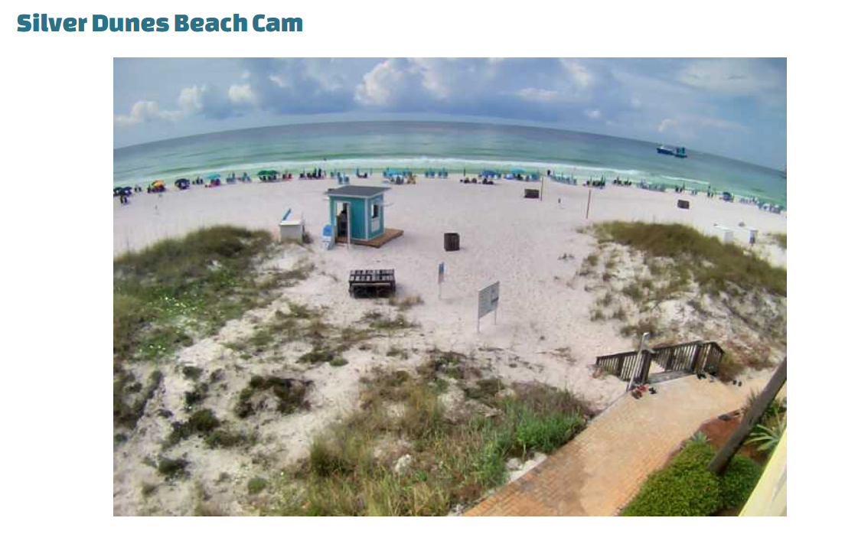

Be sure to check out the beach webcam, accessible via the [www.SilverDunesFL.com](http://www.SilverDunesFL.com) website. There is something to just being able to see our beach live when you are not there in person.

# Why is Silver Dunes Such a Wonderful Place to Invest in Your Vacation Home?

**Examples of Silver Dunes Reviews**

“Little piece of heaven is what my family has always called it!”

“For 4 generations we have been enjoying Silver Dunes! The courtyard is SO perfect for fun with kids.”

Top of Form

“Our son's baseball team chose Silver Dunes based on one of the other parent's recommendations. It was perfect! The grassy area was great for the boys to play wiffle ball when they weren't playing baseball, the beach was right there, and the parents loved hanging out by the pool where we could see the boys playing. It is a great place for families and we can't wait to come back!”

“This is our 2nd year staying here. We love it! Condos are nice, the grassy area is a real plus for the kids. The beach here is beautiful and not overly crowded. Thanks George for our chairs, umbrellas and a clean beach everyday, a super nice guy. Hope to be back next summer!!”

“We have stayed here over 50 weeks in the past 15 years. Great beach front condos. George is still keeping the beach beautiful.”

“The sun was out, the surf was up, students filled the courtyard playing games, and swimmers relaxed and visited in the beautiful pool. Silver Dunes is a jewel along the gulf like no other! Priceless!!”

“Been going for 26 years! And had a blast every time!!”

“Wouldn't stay anywhere else...Great memories of our yearly girl trips. Wish I could go more often. Every condo I have been in was comfortable and felt like home. Always hate to leave.”

Silver Dunes is a **family-oriented** vacation destination in the heart of Destin, and beloved by our owners for so many reasons:

Silver Dunes is a Year-Round Destination.

If you are only familiar with Silver Dunes during a certain time of year, consider a vacation to explore during a different season.

* Spring – We cater to families on spring break.  We do not rent to guests under the age of 25.
* Summer – Silver Dunes is a favorite with families, many of whom having been coming to Silver Dunes since they were children themselves.
* Fall – October or November is a great time for a Destin vacation.  It is still warm, the sun sets over the gulf, and most restaurants have no waiting!
* Winter – Not only are our snowbirds characters, our beach is a wonderfully peaceful place to be during the holidays.

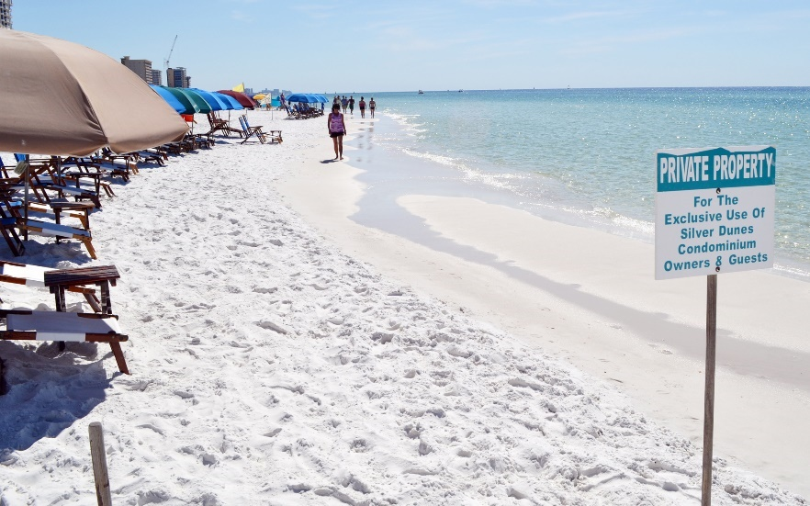

Our Private Beach.

You will not experience the crowds that are commonplace at the high-rise condos’ beach fronts. Our beautiful, private beach is solely for our boutique complex of 98 condos. And Excel beach service is exceptional!

​

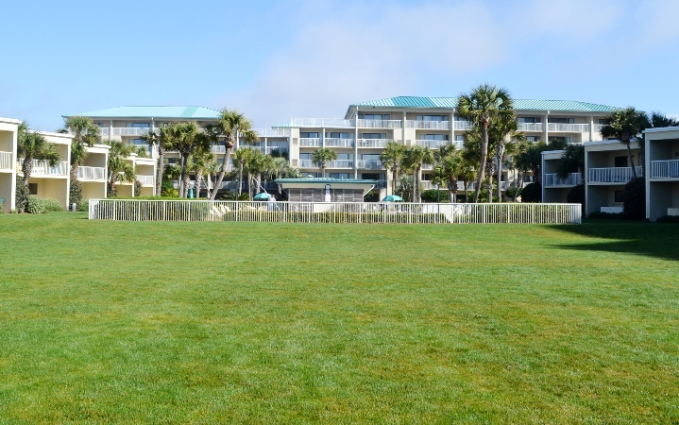Our Beloved Courtyard.

Our complex is centered around an amazing grass courtyard.  This is a very special area and truly unique to Silver Dunes. Every evening through the summer you will see kids of all ages playing soccer, frisbee, kickball, football, baseball, and more.

​

Great Condos and Great Views!

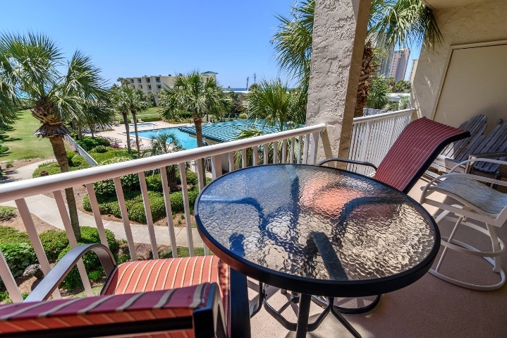Most of our 98 units have recently been remodeled.  We have 1, 2, and 3 bedroom units – each with a patio or balcony that looks out over the courtyard, pool, and/or beach.

​

Fun and Well-Maintained Grilling & Picnic Areas.

Most afternoons, you’ll find “master grillers” swapping stories and sharing charcoal.  Many of our owners and guests opt for grilling out rather than going out – particularly during the busy summer months.  Ask our management team about the best seafood markets and butcher shops in town.

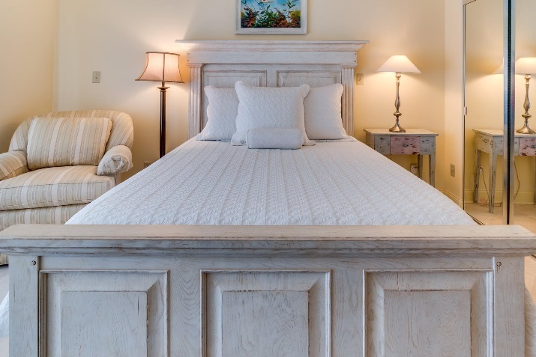**​**

Great Amenities and Beautiful Landscaping.

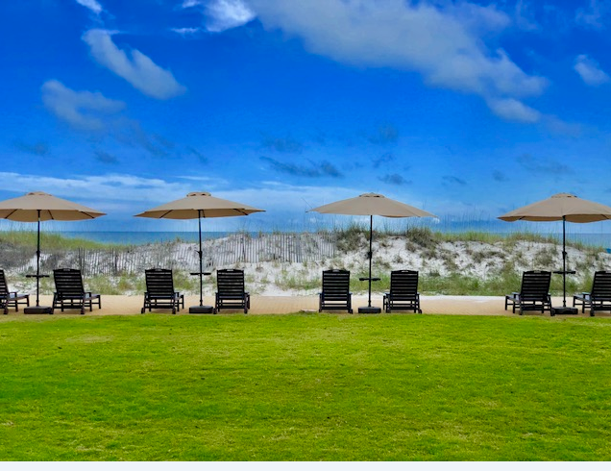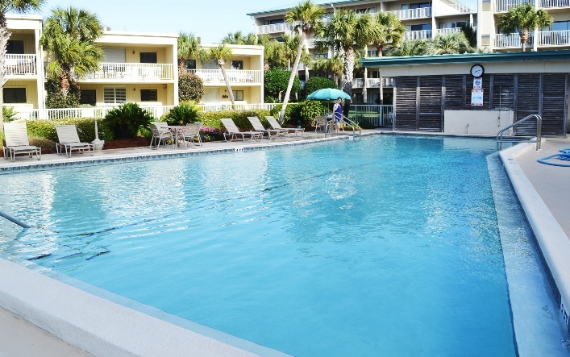From the beautiful courtyard pool (which is heated in cooler months), to lighted tennis courts and a fitness center, Silver Dunes has something for everyone. And the palm trees and oleander provide a wonderfully relaxing backdrop for any vacation.

# Property Layout and Amenities

## Beach Service:

## 

Chris Trafton and his staff offer beach service from March 1 through Nov. 31st each year, as well as wooden cabanas available for guests in the off season.

Guests can reserve beach chairs and umbrellas through Chris (by calling [**850-797-6123**](tel:+18506543169)) or by emailing info@excelbeachservice.com ). Or, guests can locate Chris at hut on the beach. He rents chairs and umbrellas as well as paddle boards and kayaks on a daily or weekly basis. He generally has the chairs up by 8:30 in the morning and begins collecting them around 4:30 in the afternoon. He’s a great aficionado when it comes to places to eat, weather forecasts and more!

Chris provides multiple options for Silver Dunes’ owners. Owners can rent beach chairs and umbrellas, just as guests do. Or owners can purchase personalized chairs/umbrellas through Chris and, for a small fee, he will set your chairs/umbrellas out each day of your visit, and then dry them out before replacing in your beach locker after your visit. Interested in a seasonal plan that both owners and guests can enjoy…call Chris today for more info.

If your unit does not have an assigned beach locker, please contact Chris for a locker assignment.

Beach charges are due prior to your check out (and can also be charged directly to your owner’s statement).

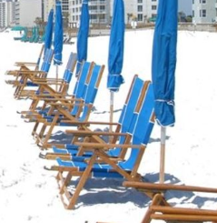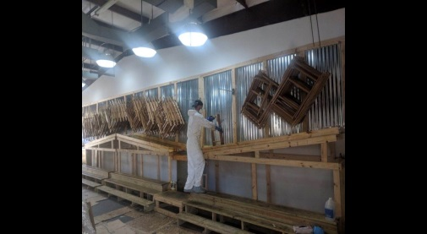

Fitness Room:

Located on the second floor of the Penthouse building. Open daily from 8:00 am to 4:30 pm. Stop by the Front Office to get a key.

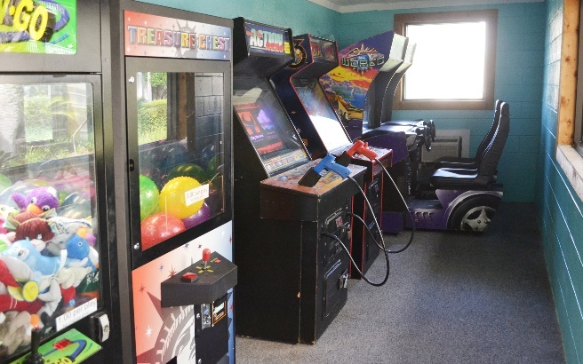

Arcade:

Open Daily 9:00 am until 10:00 pm.

Laundry Room:

Open Daily 8:00 am until 10:00 pm.

Internet Access: Silver Dunes is equipped with campus-wide WiFi, including access at the pool, courtyard, and the beach.

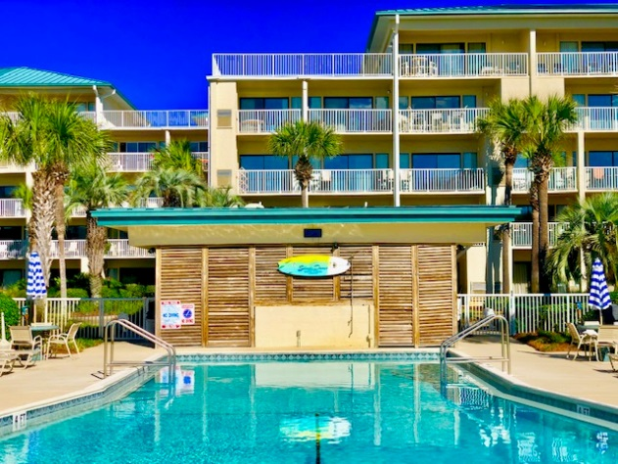Pool:

Open 9am to 10pm daily. No glasses or glass containers are allowed in the pool area. No food or drink in the pool. Pool furniture must remain in pool area. No diving, running or horse play allowed. Children under 12 must be supervised by an adult while in the pool area. No children in diapers allowed in the big pool.

Tennis Courts, Basketball, and Pickleball:

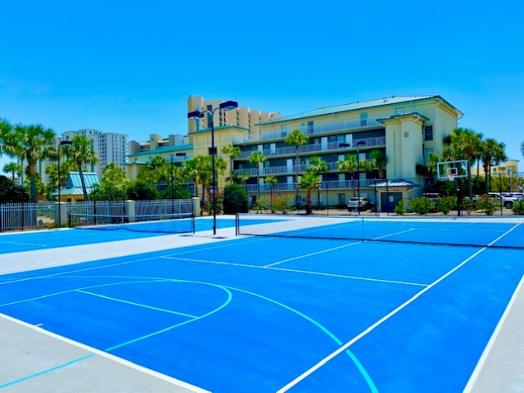Courts are open 7am until 10 pm daily. Please make reservations for the courts at the guard house after 4:30 pm of the preceding day. No scooters, skateboards, or bicycles allowed on the courts. Please wear tennis shoes or soft soled shoes only. Shirts are required to be worn while on the courts. Please be courteous and respectful of other players.

At the front desk, owners and guests can check out tennis rackets, basketballs, shuffle sticks, etc.

BBQ Grills:

There are two grilling areas: one between Building A and the Penthouse Building, and one between Building D and the Penthouse Building. You will need to provide your own briquettes. No grilling is allowed on any patio or balcony, unless using an electric grill.

Pets: Absolutely ***NO*** pets allowed on the premises except to aid the handicapped.

# Silver Dunes HOA and Financial Structure

Silver Dunes Association is classified as a non-profit, which means the HOA determines HOA monthly costs, assessments, and even rental program fees without profit. Any overage helps fund the future year’s expenses.

HOA Dues

Silver Dunes monthly HOA dues fund property expenses and reserves for major projects and capital improvements.

Specifically in regard to HOA property expenses, dues fund items including:

* Half of our property manager and accounting manager’s salaries
* The small business loan (SBA) resulting from the rebuild of Silver Dunes after Hurricane Opal (1995)
* Property and flood insurance
* 25% of Maintenance Supervisor and 50% of maintenance staff’s salaries for preventive maintenance for the property itself
* Half of the water and electricity expenses and 30% of the gas expense for the complex (in-unit electricity paid via individual owners)
* 100% of internet and cable television
* Half of Waste Management’s (dumpster emptying) monthly bill
* Service contracts for the property, most notably landscaping, pest control, fire system maintenance, pool maintenance, and elevator maintenance
* 100% of Grounds Keeper

Rental Program

The rental program funds items such as:

Rental Program Administration

* Half of our property manager and accountant’s salaries
* 100% of salaries of front desk personnel
* 50% of Maintenance Supervisor’s salary and 50% of maintenance staff’s salaries
* Property activities to attract rentals in summer and winter seasons
* Rental-specific items, such as credit card processing fees, website maintenance, reservation system, advertising, etc.
* Housekeeping management and laundry service, including:
  + 100% of salaries of housekeeping management and inspectors
  + Cost of laundry service
  + Annual purchase of linens and towels
  + Cleaning supplies
  + Starter-rental kits, including toiletries

Guest-Related Expenses

* Half of the water and electricity expenses and 70% of the gas expense for the complex (Note: Gas percentage is higher due to cost of heating pool in winter months for snowbirds)
* Half of Waste Management’s (dumpster emptying) monthly bill
* 100% of the nightly security service

Capital Reserves

* Capital projects are reviewed and approved by the Board as needed. 25% of the Maintenance Supervisor’s salary is allocated to capital reserves for project management/oversight of the capital initiatives.

The budget is determined annually, at which time HOA dues are calculated for the following year.

***Revenue from the rental program significantly reduces overall HOA operating expenses.***

***If you choose to rent your unit, please do consider leveraging Silver Dunes in-house rental program. All commissions received subsidize operating costs, fund the salaries of Silver Dunes staff, and so much more.***

***The more owners who leverage our in-house program, the more we can invest in Silver Dunes.***

## Silver Dunes In-House Rental Program

Why is the Silver Dunes in-house leasing program your best option?

We are on-site. While most complexes in Destin are managed by outside agencies, Silver Dunes is not. We have property management, accounting, front-desk, security, maintenance, and housekeeping all on-site – and solely dedicated to service at Silver Dunes. Our guests do not have to speak to management in other states, nor do our guests have to pick up keys in other locations after a long drive to town. Our management team is here to ensure our guests have the best stay possible. Need a crib rental? Want the scoop on how to get extra discounts at the outlets? Interested in local events and tourist activities? Just stop by the front desk!

We have hundreds of repeat guests each year, who book directly through the office. We have great relationships with families who have been coming to Silver Dunes for generations. Many families book multiple units and keep our bookings exceptional strong over the summer months. These guests love our complex as much as we do; they help maintain the culture we strive for, and they take care of the units they rent.

**Revenue from the rental program significantly reduces overall HOA operating expenses.** As previously stated, if you choose to rent your unit, please do consider leveraging Silver Dunes in-house rental program. All commissions received subsidize operating costs, fund the salaries of Silver Dunes staff, and so much more. The more owners who leverage our in-house program, the more we can invest in Silver Dunes.

Further, we recently explored the idea of leveraging a local Destin leasing company to manage Silver Dunes’ internal/on-site leasing services. We administered a comprehensive Request for Information (RFI) with the leading property/leasing management companies in the area. The board overwhelmingly determined that it is in the best interest of all owners for us to maintain our internal rental operations.

**By reviewing the proposals, it became even clearer what the benefits are of having our own rental operations (which is very rare for this area).** Examples include:

* Silver Dunes maintains **control** of the overall operations of the program – including rates, reputation, rules of leasing, and interaction with property management. For example, coordinating major capital projects with an outside rental company would be extremely difficult.
* Our owners have **no limitations on use of their condos**. Most outside agencies limit owner/guest occupancy, especially during the summer months. Some even stipulate free nights for promotional use.
* Outside agencies will not move a tenant to **accommodate an owner’s personal use**. While this is challenging, Silver Dunes works hard accommodate these types of owner requests.
* Silver Dunes **administers payments** of utility bills, beach service, etc., for our owners in the program. This is typically not an option with outside agencies, especially without added administration fees to owners.
* Silver Dunes can easily **bill owners’ guests** for cleaning services when owners request this, while outside agencies procedures limit billing only to the owner.
* Silver Dunes offers our owners a much **broader scope of maintenance services**. Where most outside agencies only support reactive maintenance through tenant work orders (e.g., disposal clogged, AC not working), our concierge maintenance services include small condo improvement projects (e.g., ceiling fan replacements) and acting as liaison between owners and GCs for major projects.
* While each outside agency would have team members on site, many limited the resources to the front desk. Housekeeping Management, Inspectors, and Maintenance are often not **onsite full time**. This results in slower response time, trip charges, and more.
* None of the agencies offer **towel exchange**; Silver Dunes provides this service at the Front Desk.
* Some agencies sneak in **additional fees** to owners, such as credit card processing fees. This is not the case with Silver Dunes.
* Many outside agencies also leverage travel agencies for bookings. These travel agencies require up to 20% of gross rents, prior to commissions. This can significantly reduce an **owner’s net proceeds**. Silver Dunes does not use travel agencies.

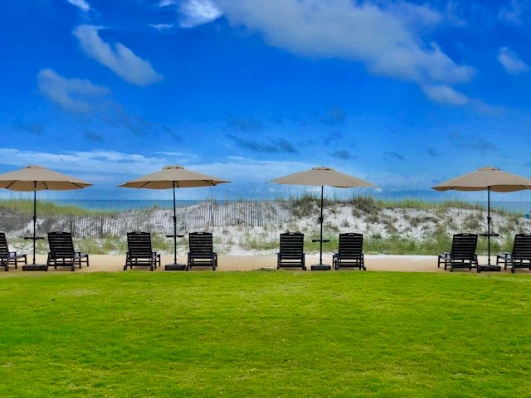

Scope of Services

In a nutshell, owners leveraging the in-house Silver Dunes rental program receive custom, top-notch services that maximizes both rental revenue and quality service:

* Advertising and promotion of unit to attract guests, including website and reservation system
* Coordination of keys, check-in and check-out by the Front Desk
* Guest services, including after-hours calls
* Oversight and coordination of cleaning services, laundry services, and unit inspections (cleaning fee passed through to guests)
* Oversight and coordination of in-unit maintenance
* Bookkeeping and financial reporting
* Payment of monthly invoices, such as utilities and telephone (if applicable)
* Receipt and disbursement of rental proceeds, including cost of credit card processing
* Wooden chaise lounges in winter months

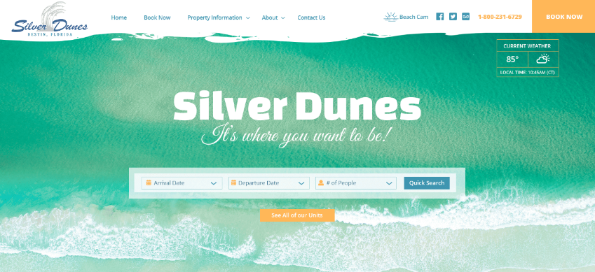Marketing Your Unit

Our leasing team leads a host of initiatives to market your unit, including:

* 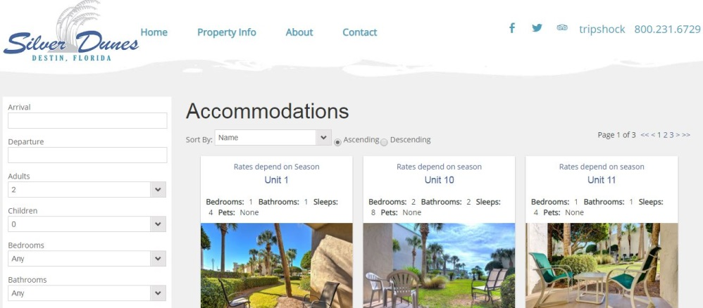Modern website, including Google Search Engine Optimization (SEO)
* Industry’s premier reservation system, Escapia (developed by HomeAway.com)
* Additional marketing channels, including VRBO, HomeAway.com, Expedia, TripAdvisor, and more
* 1,000+ current and past guests on email group and Facebook; ongoing communications across all channels
* Advertisements via Google AdWords
* Professional photography of your unit
* Ability to add videos of unit (pass-thru fee)

***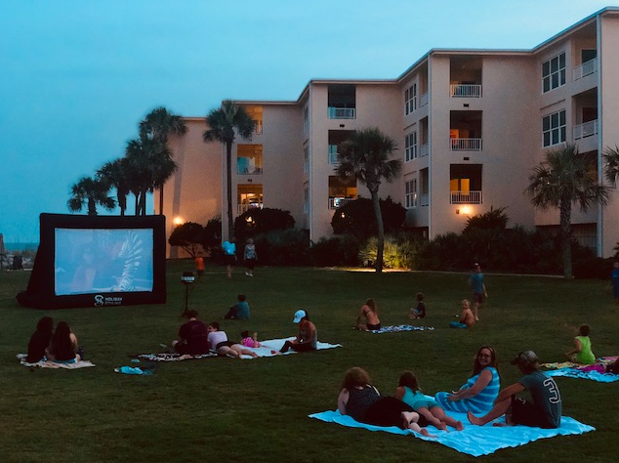***Summer Family Activities

***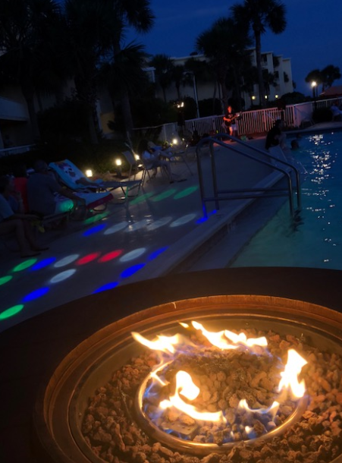***During the summer months, the Silver Dunes Rental Program hosts evening activities to further our family environment:

* **Movie Night Mondays:** Join us in the courtyard to watch a family-friendly movie on our new 20ft blow-up big screen. Movie starts at sunset.
* **Wednesday Smores Night**: Have a sweet treat with friends and family around one of our two fire barrels.

These events take place from 7pm- 9pm (sunset for movies/weather permitting) and are open to everyone! What better way to make memories than by giving our owners and guests something that their families will remember for a lifetime!

Snowbird Program

**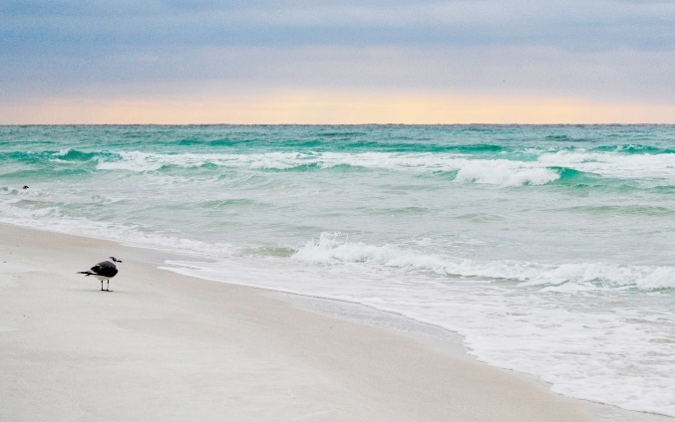**Silver Dunes Rental Program has a large number of monthly snowbird rentals each year, from December through the end of February. During this time of the year, Silver Dunes Rental Program coordinates a host of weekly events:

* Monday, Wednesday and Friday: Water aerobics in the heated pool
* Thursday: Ladies’ Coffee
* Wednesday: Bunco
* Friday: Cocktail Hour

\*days subject to change

Maximizing Your Rental Revenue

The Rental Program monitors leasing rates in the area via market comparison studies. We compare our rental rates, cleaning fees, reservation fees, and amenities to comparable complexes in order to stay competitive, while maximizing our owners’ rental revenues. Analysis is prepared by unit size and by each season of the year.

Further, the Rental Program offers a host of services to keep your expenses in line. Unlike other agencies, the Silver Dunes Rental Program does not charge owners for credit card processing fees. The Silver Dunes program provides free lightbulb and filter changes. In-unit maintenance is billed in 15-minute increments; and given in-unit maintenance is provided by Silver Dunes’ staff, there are no trip charges and drive-time charges.

Silver Dunes passes through cleaning fees to guests. Other than annual deep cleaning (or personal stays), owners in the Rental Program are not paying guests’ cleaning fees out of their rental revenue.

Leasing Program Communications

* Emails and phone calls to Property Manager and Front Desk: Emails and calls are always responded to within the day, and typically within the hour.
* 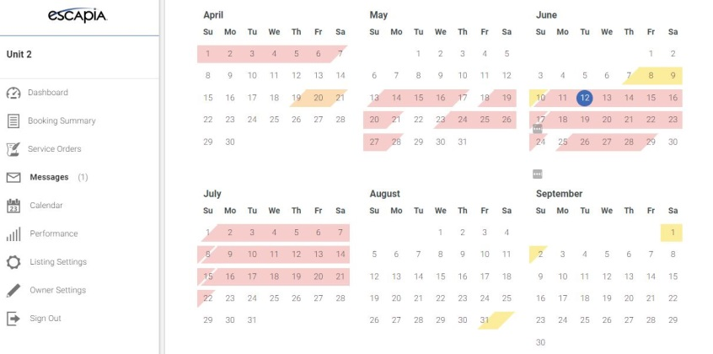Owners Portal: Through our Escapia system, we offer owners a portal with tools and features to track revenue and overall trend performance.
* Financial Reporting: Our Accounting Manager provides monthly and annual statements, inclusive of rental revenue and expenses (HOA dues, commissions, beach service, utilities, etc.)
* Auto Deposits: ACH transactions are posted on the 10th of each month

**Competitive Management Fees** – *Low commission rates and no hidden fees!*

* No credit card processing fees
* No annual linen fees
* Guests pay cleaning fees
* Direct deposit of rental proceeds
* Onsite management staff
* No limits to owner and owner-guests usage

**Online Owners Link** – *Real time access to the information you need!*

* Make owner stays and owners guests stays with online reservation software
* View future reservation details and projected income
* View booking calendars
* Review owners statements

**Expert Reservations Sales** – *Our front desk has client service as their #1 priority!*

* Knowledgeable reservationists with personalized sales skills
* Trusted computer systems and software – Escapia
* Sales tax processing

**Comprehensive Marketing Campaign** – *Targeted to promote families, not rowdy crowds!*

* Direct advertising. Automatically be enrolled in Expedia Market Group along with VRBO, Homeaway, and all their partnered sites at no cost
* [www.silverdunesfl.com](http://www.silverdunesfl.com)
* Social Media (Facebook, TripAdvisor, tweeter and more!)
* Target email campaigns
* Direct email campaigns
* Interactive media

**On-site, Professional Staff** – *Being on-site makes a world of difference!*

* Direct on-site check in
* Restaurant and activities recommendations through the front desk
* Games and movies available at front desk
* Housekeeping, inspections, and maintenance – ALL ONSITE!
* Coordination of contracted services through on-site Maintenance Supervisor (carpet, tile HVAC, etc.)

**High Quality Housekeeping and Linen Services**-

* Property inspections daily
* Assigned inspectors to your unit
* Pre-arrival freshen-ups
* Departure cleaning with commercially cleaned linens
* Deep cleanings each winter
* Luxury quality Linen Pool – No annual linen cost

**Maintenance Service** – *On-site, Trusted Professionals, who care!*

* Routine and preventive maintenance with onsite maintenance staff
* Comprehensive preventive maintenance Inspections
* Hurricane preparations and recovery
* Appliance installs and removals

SILVER DUNES

**RENTAL PROGRAM BENEFITS**

# Housekeeping Services and Property Inspections

Owners in the rental program and owners who do not use an outside rental agency have access to Silver Dune’s housekeeping services.

Highlights of our housekeeping program include:

* Silver Dunes has housekeeping inspectors assigned to each building. After each departure, and before every arrival, your inspector will walk your unit. If your unit is on the rental program and unoccupied, your unit will also be walked daily. This helps ensure no one is in your unit that shouldn’t be, no water is running, A/C isn’t turned too low, etc. Plus, keeping the same set of eyes on your unit will help with reporting of maintenance issues and any damages caused by guests.
* Silver Dunes leverages an outside vendor service to wash, dry, and fold our towels and bed linens. By doing this, we are able to leverage our internal housekeeping team for inspections—rather than laundry service.
* Silver Dunes uses high-quality, name-brand cleaning supplies.
* Each unit is stocked with a large number of towels at the beginning of each stay. Guests have the opportunity to stop by the front desk during the week and pick up an additional pre-bagged towel set without the hassle of bringing original towels to exchange.
* Each unit is also stocked with a set of starter supplies, including soaps, toilet paper, paper towels, dish detergent, shampoo, conditioner, and make-up removal wipes.
* For units in the rental program, during the winter months your unit will be deep cleaned, as well as given a unit condition report for suggested owner improvements. Housekeeping will also complete a comprehensive inventory inspection of required items (e.g., iron, kitchen utensils, drinking glasses, pot/pans) and restock necessities as appropriate (at cost).

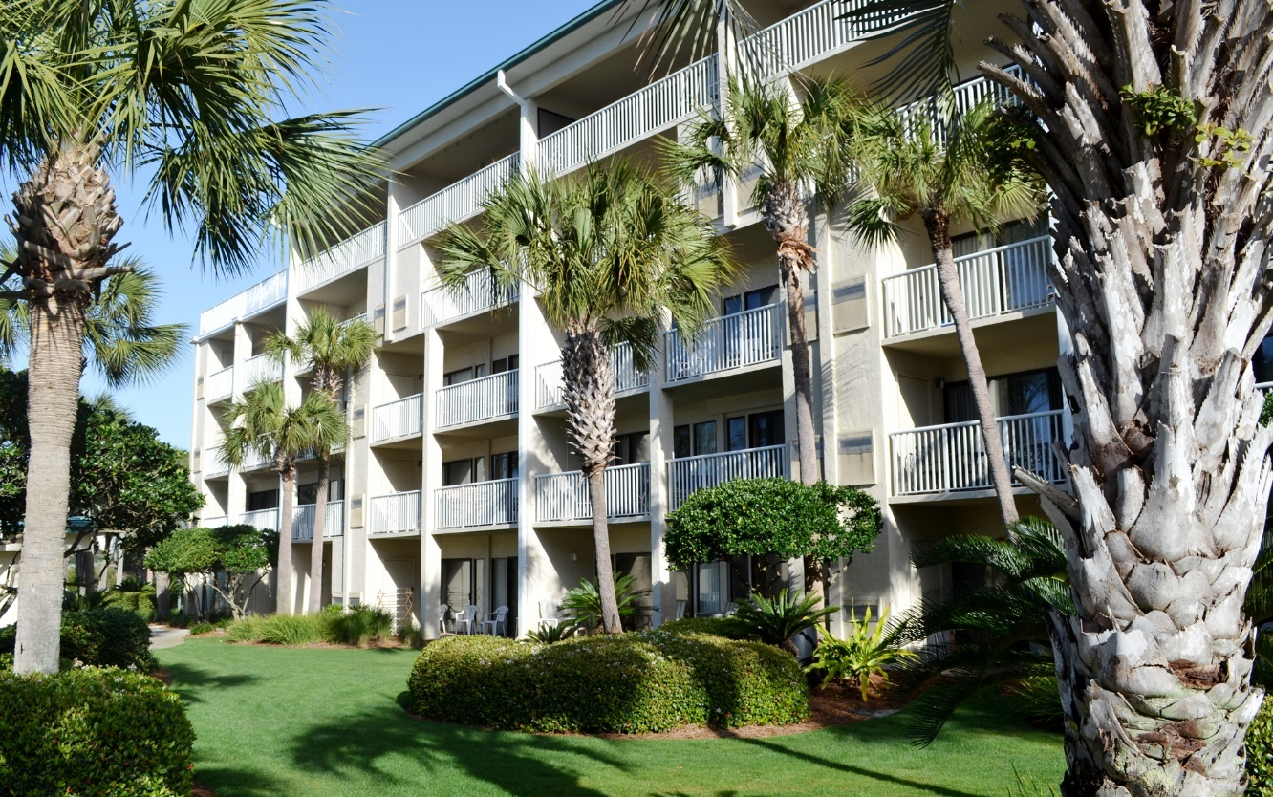

## Maintenance Services

Silver Dunes maintenance provides certain in-unit services to all owners, as part of monthly HOA fees, including changing of HVAC filters and light bulbs.

Silver Dunes also keeps maintenance personnel on staff to support our owners’ in-unit maintenance needs (hourly rates apply, plus cost of supplies).

Owners can request the following maintenance services through Silver Dunes, billed in 15-minute increments or purchase the \*optional maintenance plan for $500 a year which would cover such request below.

* **Handyman**: Small interior repairs (such as installing owner’s closet locks, hanging artwork and flat-screen TVs)
* **Appliances**: Service, installation, maintenance
* **Electrical**: Outlets, switches, etc.
* **Cabinetry**: Repairs, touch-up finishes, adjust drawers and doors, replace hardware
* **Interior Painting**: Individual Rooms, Settling and Crack Repair, Touch-Ups
* **Plumbing**: Drain clogs, fixtures, pipe leaks, shower heads, toilets (repair/replace)
* **Refuse Removal**: Coordinating removal of appliances and furniture
* **HVAC**: Minor repairs (outside companies are called for major repairs)

\*Note: Additional services, such as installing ceiling fans, TVs, appliances, new disposals, toilets, and overseeing contractors in the unit are billed at hourly rates.

**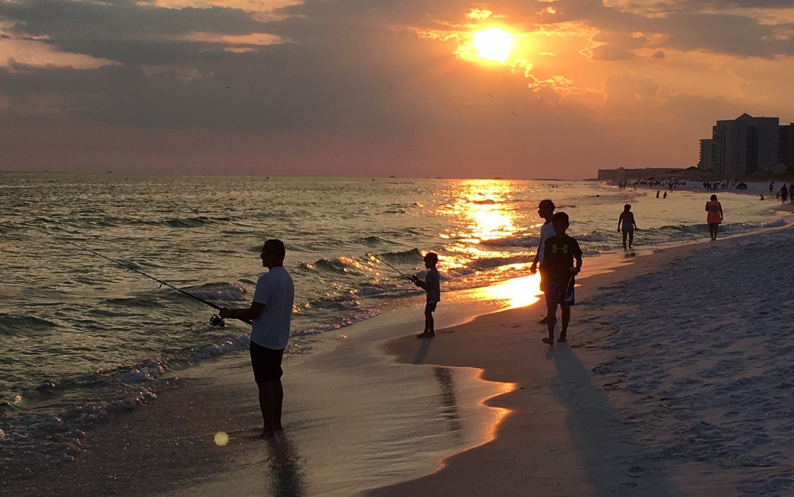Silver Dunes staff is not equipped to provide major remodeling projects or concierge services.**

# HOA Dues and Pricing of Supplemental Services

HOA Dues

Monthly dues are based on the forecasted operating expenses for the year, plus reserves for major projects, painting, etc. 2024 dues are $1250/month.

Rental Program Commission Rates

Owners in the rental program pay commissions as follows:

* 20% commission rate for 1 bedrooms
* 25% commission rate for 2 bedrooms, 3 bedrooms, and 2 bedroom TH

Owner Administrative Fee

Silver Dunes does not charge an administrative fee for personal (non-commission) guest check-ins for family and friends.

Tenant Administrative Fee

$150 fee per reservation for all tenant (i.e., revenue-generating) reservations. This includes rental agencies and self-rentals (e.g., VRBO listings). There is no cap on number of reservations.

* For those leveraging the in-house Silver Dunes rental program, this fee is reimbursed by Silver Dunes Rental Program. Owners will see both a debit and a credit for each reservation.
* For those not utilizing the Silver Dunes Rental Program, the fee(s) will be added to your monthly HOA statements. Owners using outside agencies may consider asking your rental companies to reimburse you for the fee (as Silver Dunes Rental Program will do for those in our program) or pass the fee on to your renters.

Linen Program

Rental Program: $600 one-time linen fee for owners in the Rental Program.

Resort Fee

$100 Resort Fee per reservations will be added to any new reservations made after Jan. 1st, 2024 (this is only applied to bookings made directly through SD onsite office/website).

Cleaning Services

Rates are set annually. 2024 rates are:

|  |  |  |
| --- | --- | --- |
|  | Non-Rentals/Self-Rentals  (Actual Cost) | Rental Program  (Subsidized thru Commissions) |
| 1 BR | $205 | $165 |
| 2 BR | $275 | $210 |
| 3 BR or TH | $350 | $255 |

*FAQ: Why do renters pay less than non-renters? Rental program cleaning fees are subsidized by a portion of the rental owner’s 25% commission rate.*

Maintenance Services

|  |  |  |
| --- | --- | --- |
|  | Non-Rentals/Self-Rentals  (Actual Cost) | Rental Program  (Subsidized thru Commissions) |
| Hourly Rate | $100.00 per hour, billed in 15-minute increments | $75 per hour, billed in 15-minute increments |
| Trip Charge | Silver Dunes does not charge trip fees, given our maintenance team is on-site. However, if one of our staff members must make a trip to a local store to purchase supplies specifically for your work order, a minimum 60-minute charge will apply. | |

*FAQ: Why do renters pay less than non-renters?*

*Rental program maintenance is subsidized by a portion of the rental owner’s 25% commission rate.*

Optional Maintenance Plan

For those in the rental program as well as non-rental owners, Silver Dunes offers an optional maintenance program of a base tenant-related scope of services at a set fee of $500/year. Scope of services is provided below. Please contact the front desk if you would like to participate in this program.

Annual Maintenance Plan Scope:

* Diagnostic service calls (A/C and heating, appliances, electrical, plumbing and internet)
* Unclogging toilets, sinks and tubs with normal use of plungers
* Replacement of easily accessible standard A/C and heating filters on maintenance schedule (excluding specialty filters)
* Clear jammed/clogged disposals and re-setting of disposal motors
* Replacing sink stoppers
* Installing flapper valves in toilets
* Installing toilet flush arms
* Checking and re-setting electrical breakers and ground fault interrupter outlets
* Adjusting refrigerator and freezer controls
* Replacement of all easily accessible light bulbs
* Replacement of batteries for remote controls
* Replacement of batteries for easily accessible smoke detectors
* Re-programming of electronic component remote controls
* Re-installing towel bars and rods
* Installing door stops and tips
* Tightening and adjusting cabinet doors, hinges and toilet seats
* Replacement of electrical and cable cover plates (excluding decorative covers)
* Lubricate and adjust door mechanism, as necessary

Note: Additional services, such as installing ceiling fans, installing toilets, and overseeing contractors in the unit are billed at stated hourly rates.

## Recap of Service Offering and Pricing

In recap, these are the various service options available to owners:

|  | Non-Renting Owner or Owner Renting on His/Her Own | Owner in the Rental Program | Owner Renting Via Outside Agency |
| --- | --- | --- | --- |
| Commission Rates | N/A | 20% 1 bedrooms  25% 2 bedrooms, 3 bedrooms, & 2 bedroom TH | N/A |
| Coordination of keys, check-in and check-out by the Front Desk | Owners must complete an owner booking form (see following page) and email to [info@silverdunesfl.com](mailto:info@silverdunesfl.com) | Included in Commissions | N/A  Outside agency responsible for organizing/delivery of keys to guests.  Agency must send Silver Dunes guest information prior to each arrival |
| Guest services, including after-hours calls | If you are *renting* on your own, as a courtesy we ask that you direct all after hours requests to yourself, rather than to our on-call Rental Program team. | Included in Commissions | N/A  Guests must contact the respective outside agency directly.  Should outside renters contact Silver Dunes after hours, Property Manager’s time will be billed to the Owner at $100/hour, billed in 60-minute increments. |
| Advertising and promotion of unit to attract guests, including web-site and reservation system | N/A | Included in Commissions  Automatically be enrolled in Expedia Market Group along with VRBO, Homeaway, and all their partnered sites at no cost | N/A |
| Bookkeeping and financial reporting | N/A | Included in Commissions | N/A |
| Payment of monthly invoices, such as utilities and telephone (if applicable) | N/A | Included in Commissions | N/A |
| Receipt and disbursement of rental proceeds, including cost of credit card processing | N/A | Included in Commissions | N/A |
| Cleaning Fee | Fees set each year | Fees set each year | N/A |
| Linens and Towels | N/A | $600 fee when joining the leasing program | N/A |
| Oversight and coordination of in-unit maintenance | $100.00/hour, billed in 15-minute increments | $75/hour, billed in 15-minute increments | N/A |
| Use of Chaise Lounges in Winter Months | Can be leveraged with fee paid to Silver Dunes Rental Program | Included in commissions (Silver Dunes Rental Program pays Excel Beach Service a monthly fee in winter months for these lounges) | Can be leveraged with fee paid to Silver Dunes Rental Program |

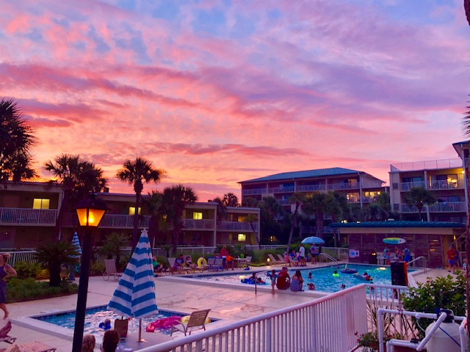

# Owner Booking Form (form to be completed for Owner Guests)



# Questions, Comments?

Please reach out to Derek Maxwell, Silver Dunes General Manager, with any questions or comments.

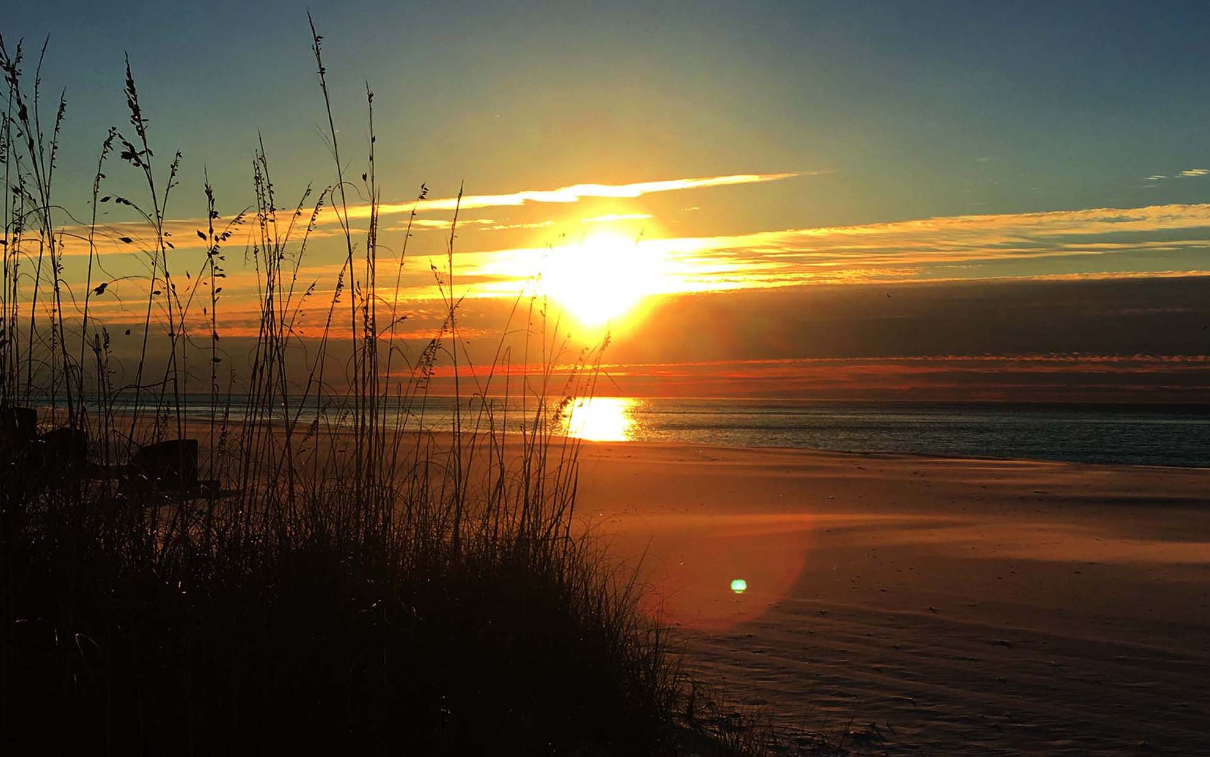

.

It’s Where You Want To Be.